Spondaic Meter

📏 What is Spondaic Meter
# Source: Chatgpt (GPT-4-turbo) at [8/2/2025]
Spondaic meter is a poetic meter where the dominant metrical foot is the spondee — a foot made of two stressed syllables:
/ / → DUM-DUM
However, pure spondaic meter is extremely rare in full poems, especially in English, because it creates a heavy, slow, emphatic rhythm that’s hard to sustain naturally in speech.

🧱 Structure
# Source: Chatgpt (GPT-4-turbo) at [8/2/2025]
- Composed of spondees ( / / )
- Usually mixed with other feet, especially dactyls or iambs, in classical verse

📝 Example (constructed in English)
# Source: Chatgpt (GPT-4-turbo) at [8/2/2025]
Dead weight, hard stone, black night, cold steel
→ Every foot here carries two stressed syllables.
Note: English doesn’t naturally produce extended spondaic lines, but such sequences appear in phrases for emphasis.

🔀 Variants / Usage
# Source: Chatgpt (GPT-4-turbo) at [8/2/2025]
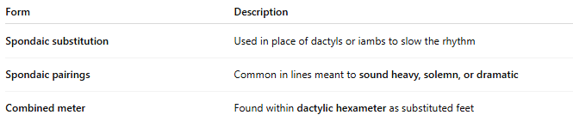
Form | Description
Spondaic substitution | Used in place of dactyls or iambs to slow the rhythm
Spondaic pairings | Common in lines meant to sound heavy, solemn, or dramatic
Combined meter | Found within dactylic hexameter as substituted feet

🧬 Poetic Use & Effect
# Source: Chatgpt (GPT-4-turbo) at [8/2/2025]
- Adds weight, gravity, or force to specific moments in a poem
- Used to slow down or punctuate emotional, martial, or tragic moments
- Conveys intensity, deliberateness, or strain

🏛️ Where It’s Found
# Source: Chatgpt (GPT-4-turbo) at [8/2/2025]
- Classical poetry (Greek & Latin), where syllable length mattered more than stress
- Epic poetry (as occasional substitution in dactylic hexameter)
- English poetry in isolated instances:
  - “Break, break, break / On thy cold gray stones, O Sea!” — Tennyson
→ “Break, break” is spondaic.

